Janice J., Deandra S., Hadel S.
Children’s Book Second Draft

Topic- Educating children on vaccines and how to be proactive (will be transferred to a PowerPoint)

Section 1- Explain the origin/evolution of vaccines
Slide 1:
For as long as people have walked this planet, viruses have bullied us into getting sick. Our ancient Egyptian friends have dealt with the speckled monster. The speckled monster left its mark on every sick person’s face and body. What a disgrace that we couldn’t help those who got sick. Not even a little bit.
(insert picture of speckled monster attacking Egypt/pyramids)
Slide 2: In the 1700s, a curious physician named Edward Jenner stumbled upon the milkmaids who could fight off the bullies with no effort at all! Edward Jenner had to know, was it the milk they sell? The cows they cared after? What he found changed the world anew!
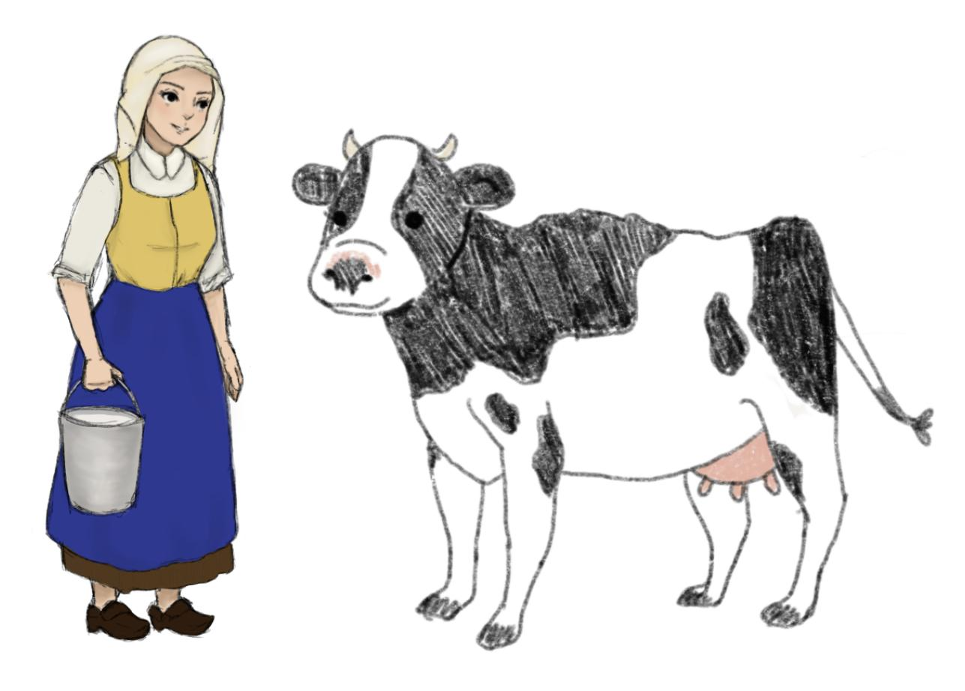
Slide 3:
Edward Jenner looked for a milkmaid, one he could trust. He came across Sarah Nelms, and she was of great help. She had cowpox on her hands, a bully of the cow. Edward took that bully onto the arm of a little boy. What happened next changed our fate. The speckled monster tried to bully the boy, but the boy already knew him. He fought him well, so now all is well.

- https://www.ncbi.nlm.nih.gov/pmc/articles/PMC1200696/

Section 2- how it's significant to our lives
- Explain the negative impact or overall impact of these monsters on us humans
- Explain the importance of why these monsters must be prevented
- Transition into the purpose and positive impact of the vaccines and how they can get rid of these monsters
Section 3- how it can be implied to the lives of children
- how vaccines protect them from “speckled monster”
- Tips/Things to do so the speckled monster won’t attack them

